**Bénard-Marangoni Film Instabilities**

Course Project for CL336: Advanced Transport Phenomena

**Submitted by:  
Group 2**

Awasthi Gaurav (200020036)  
Parth Manish Dani (200020090)  
Sumit Kumar (200020145)

**Project Mentor:**  
Prof. Jason R. Picardo



Department of Chemical Engineering  
Indian Institute of Technology Bombay  
Autumn Semester, 2022-23

### Introduction

The Rayleigh-Taylor instability describes an interfacial instability that results when two fluids of different densities are in contact with each other, specifically, when the less dense fluid “pushes” the heavier one [[1](https://www.google.com/url?q=https://en.wikipedia.org/wiki/Rayleigh%25E2%2580%2593Taylor_instability&sa=D&source=docs&ust=1669466438367371&usg=AOvVaw2Mj3CMGy3P604SEitZXP5s)].

An everyday example is that of a heavier liquid on top of a lighter one, say, water on top of oil. The interface in this case is unstable to any perturbation – as the denser fluid (water) moves down, there is a decrease in potential energy and the oil moves upward. Due to the pressure differences generated, a non-linear feedback mechanism ensures that the disturbances keep on growing.

In this report, we consider a simple liquid film suspended from a ceiling subject to the Rayleigh-Taylor instability. Gravity acts as the destabilising force in this case, supporting any perturbations in destabilising the system while surface tension acts as a “restoring force” of sorts, trying to dampen out any instabilities and opposing the increase in area that would result from the perturbations.

The interplay of these two forces is further complicated by a temperature difference between the ceiling and the ambient. A temperature gradient (in the vertical direction) within the film is introduced, thus changing the temperature along the peaks and troughs of the perturbed interface. Since surface tension is a temperature-dependent quantity (it decreases with an increase in temperature), the restoring force at each point along the interface changes. This results in the Bénard–Marangoni instability which is analysed in this report.

### Problem Statement

The aim of this project is to study Bénard–Marangoni instabilities in a system of a liquid film suspended from a ceiling. This liquid is denser than the air below it, and the air can be assumed to exert negligible pressure on the liquid film.

We aim to understand the stability and instability criteria for the liquid film, and how it evolves upon changing the relative temperature difference between the wall and the ambient.

### Assumptions and Derivation

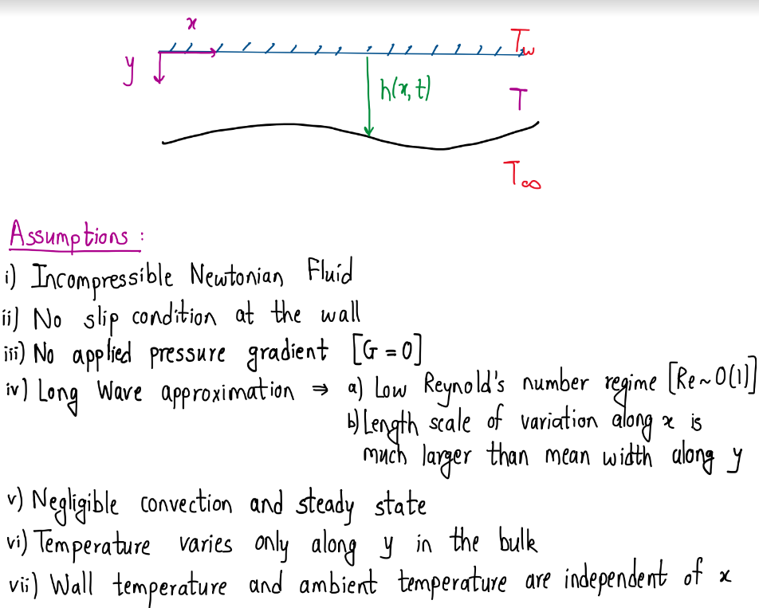

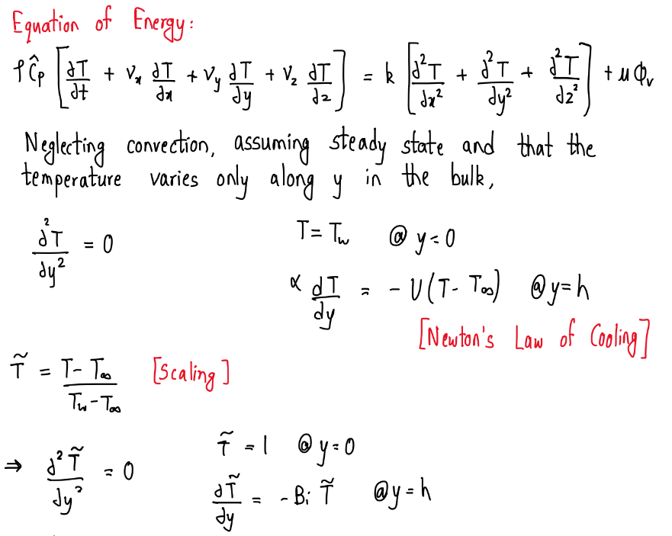

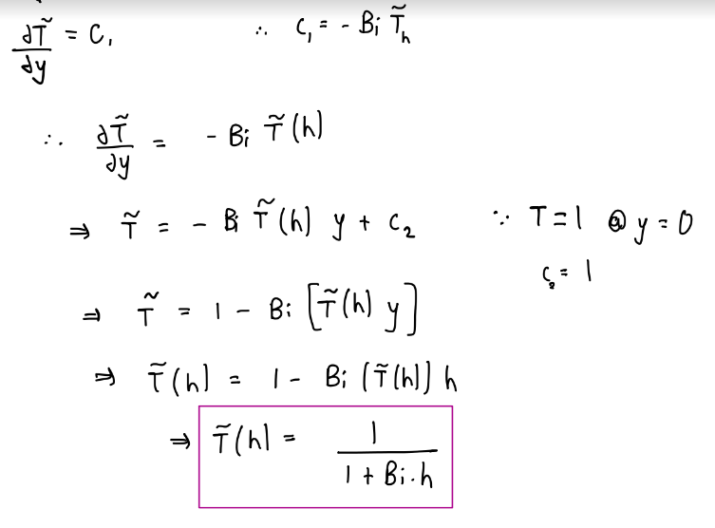

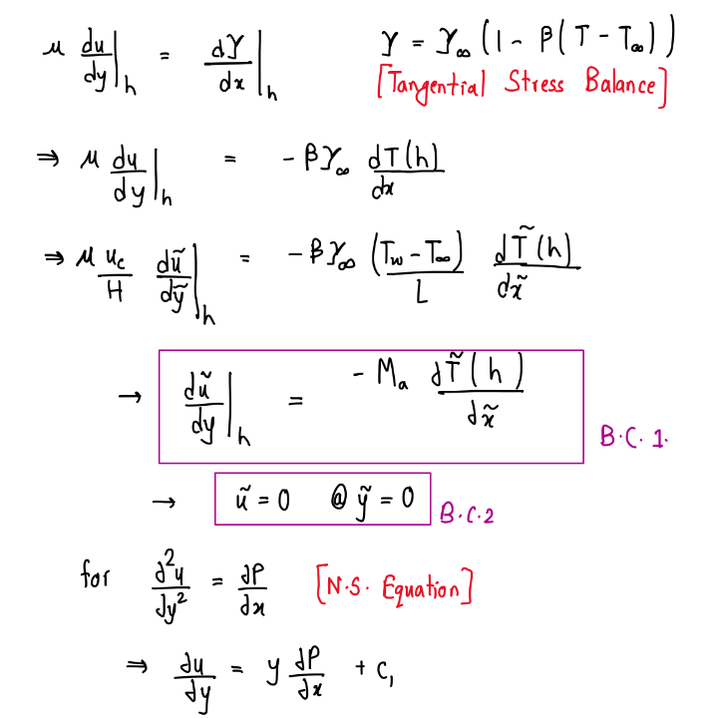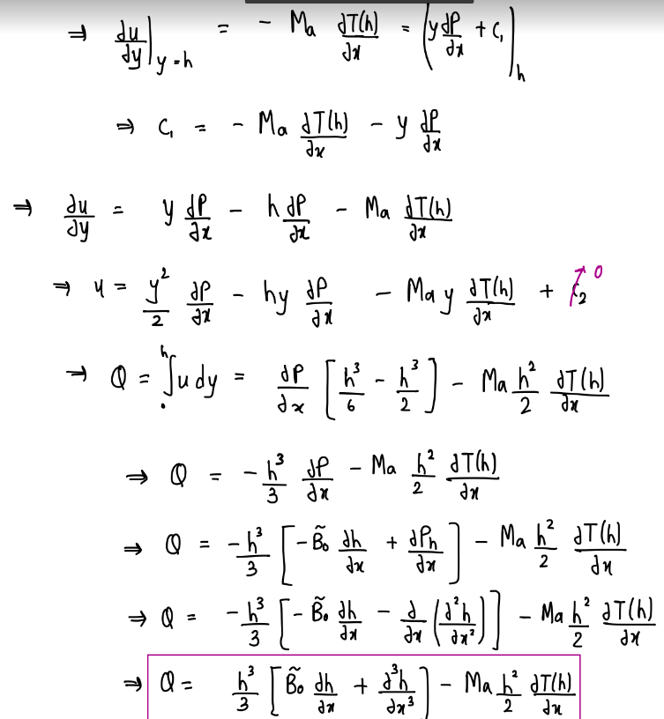

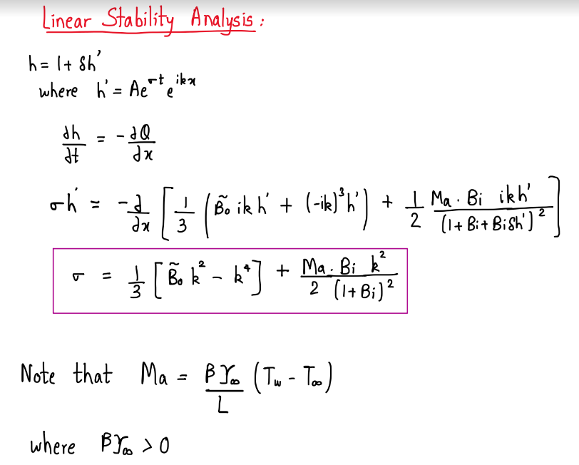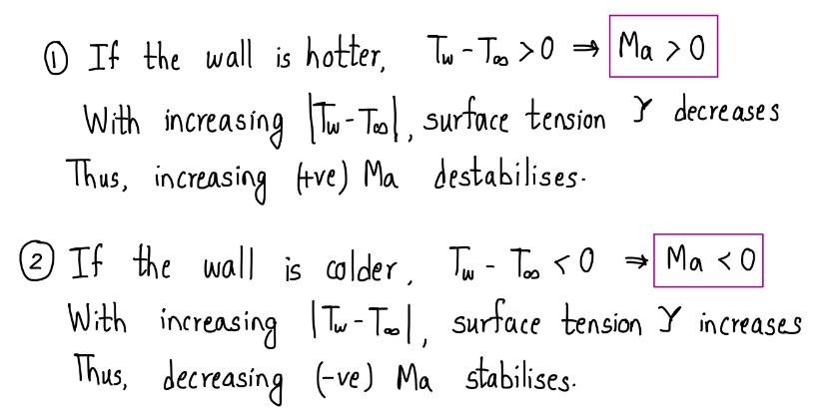

### Results and Discussion:

Biot Number (Bi) is **1** throughout the analysis unless otherwise specified.

#### The stabilising effect of a negative Marangoni number

1. We know how higher Bo number destabilises the film. If we tune in Ma=0, we get the Rayleigh-Taylor Instability, as shown below for Bo= 2 and k= 0.5

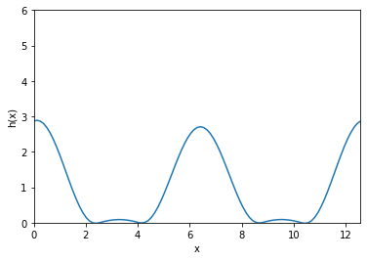

1. However, as we decrease the Marangoni number, the Marangoni term starts nullifying the Bo number term. For instance, at Bo=2, Ma= -2 and k= 0.5, we observe reduction in the number of peaks and the central part of the film getting flat.

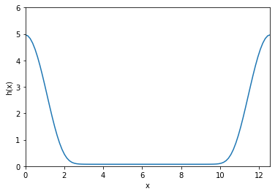

1. For Bo= 2, Ma= -4 and k= 0.5 now, the number of peaks remain the same but the height of corresponding peaks reduce. Clearly, the film is approaching the base state.

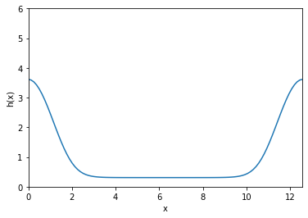

1. If the Marangoni number is further decreased, the peaks become less significant until the stabilising Marangoni number term completely dominates the destabilising Bond number effects. For the same Bond number, Bo= 2, with Ma= -6 and k= 0.5

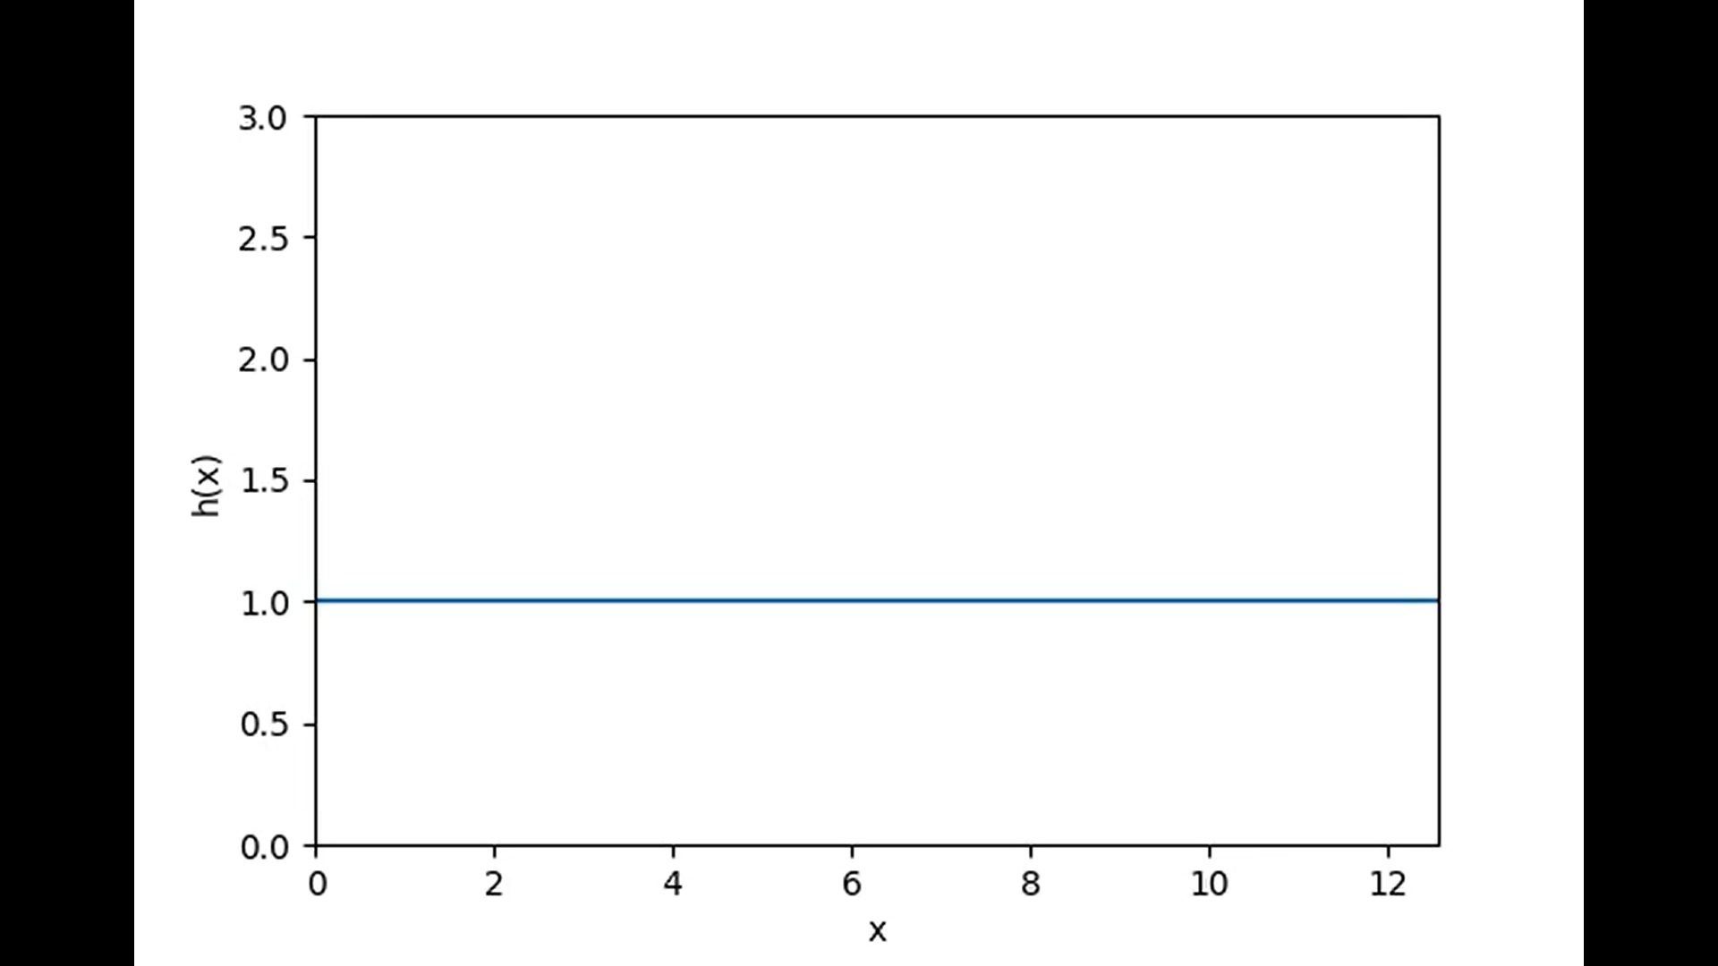

All the time dependent developments of the above segment of results can be found [here](https://drive.google.com/drive/folders/1CtFqH4Y9OY63dchoJmI2L-v1wyTtnJVs?usp=share_link).

#### The destabilising effect of a positive Marangoni number

1. Let us perform a similar analysis as in the case of stabilising effect. When Ma= 0, that is, no temperature effects, and Bo= 0.1 and k= 0.15, only the Bond number term contributes to the instability.

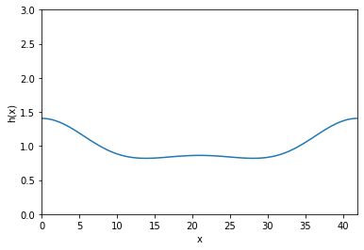

2. As we increase Ma in the positive direction, the wall gets hotter thus reducing the surface tension and adding up to the instability. For instance, if Ma= 0.1, when Bo= 0.1 and k= 0.15 we see that the number of peaks have increased.

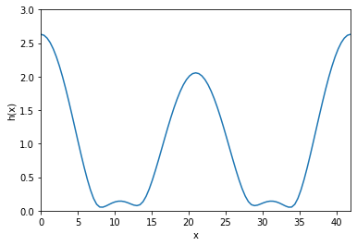

2. Further increase in the Marangoni number shows how the instabilities further intensify and the buckling becomes more evident. For instance, Ma= 0.15 when Bo= 0.1 and k= 0.15

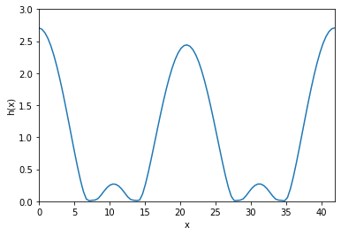

3. Additional peaks become evident (secondary and higher troughs [2]) and we can see the development of secondary buckling when Ma= 0.25, Bo= 0.1 and k=0.15

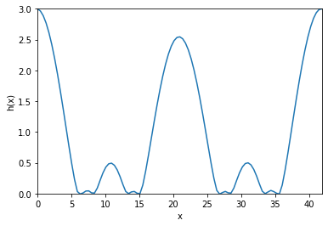

All these results with growing time steps can be found [here](https://drive.google.com/drive/folders/124Q3I6LDjtdNjFtrlcfSMBEiFbCZjl2B?usp=share_link).

#### Evolution of purely Marangoni-type instabilities

In this section, we aim to see the behaviour of a purely-Marangoni film system, i.e., one in which the Rayleigh-Taylor contribution to the instability is 0.

From the linear stability analysis, in order to neglect the Rayleigh-Taylor contributions to the instability, we must have

Choosing and thus we have attempted to show the evolution of the system at various Marangoni numbers. The complete videos can be found [here.](https://www.google.com/url?q=https://drive.google.com/drive/u/0/folders/16-wo4u7FPwVCOrs2CPn-PO5EUyj6kITv&sa=D&source=docs&ust=1669477853443977&usg=AOvVaw0wpuB0q17mHIS6SoKYD80X)

1. Bo=0.09, Ma= -6 at k= 0.3

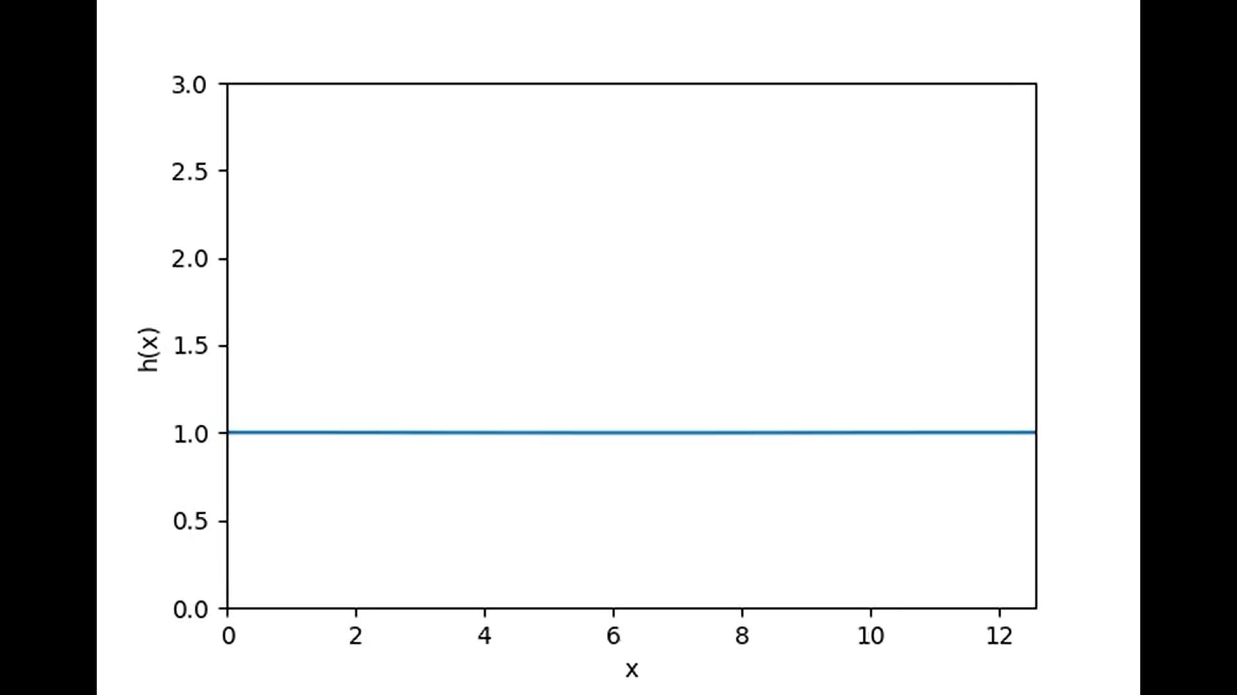

As expected, at sufficiently negative Marangoni numbers, the system is stable.

1. Bo=0.09, Ma= 0.4 at k= 0.3

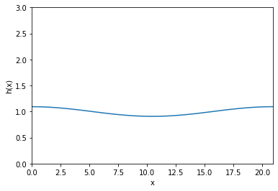

As the Marangoni number is increased, we see the system becoming unstable and the perturbations becoming visible.

1. Bo= 0.09, Ma= 0.07 at k=0.3

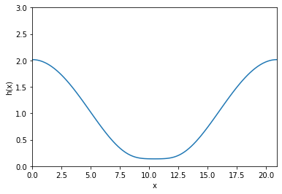

If we further increase Ma at this k, h(x) becomes negative and thus the solution diverges (physically, the film breaks and the liquid falls off)

#### The relative strengths of the Rayleigh-Taylor and Marangoni effects

Through this set of simulations, we aimed to analyse the behaviour in the case of a positive Marangoni number and a non-zero, positive Bond number independently. With both contributing to the instability of the film, we aimed to find which of the effects is stronger, that is, leads to more instability. All of these simulations are performed at the same mode, , and the Biot number is maintained at throughout..

We have accomplished this by first setting and varying the Marangoni number from 0.05 to 0.30 in steps of 0.05. The complete videos can be accessed [here](https://drive.google.com/drive/folders/1NXn0M3xx9q_ZD2nE1I796Dd2ZZ1xcUJ7?usp=share_link), and some illustrative snapshots are shown below:

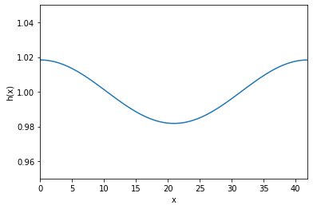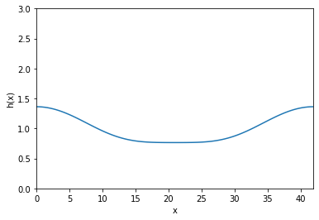

Bo = 0.0225, Ma = 0.1 Bo = 0.0225, Ma = 0.2

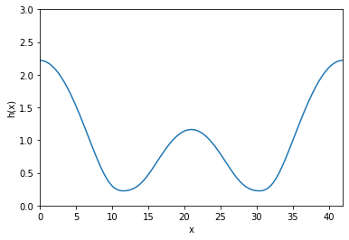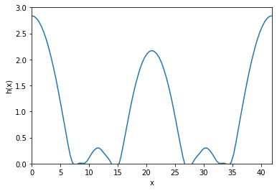

Bo = 0.0225, Ma = 0.25 Bo = 0.0225, Ma = 0.35

As expected, we see that the instabilities increase as the Marangoni number becomes more positive. However, the solution diverges at Ma = 0.35 and above.

We next change the value of Bo similarly while setting

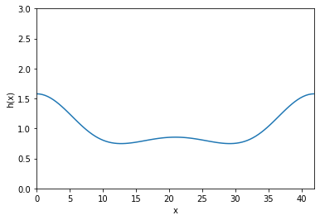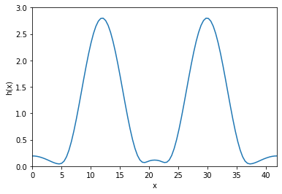

Bo = 0.1, Ma = 0 Bo = 0.2, Ma = 0

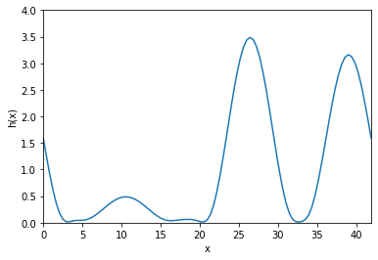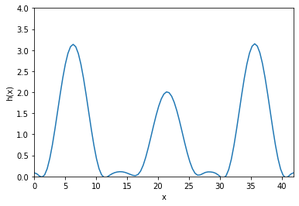

Bo = 0.3, Ma = 0 Bo = 0.4, Ma = 0

We clearly see that the “magnitude” of instability, assuming it can be quantified by the amplitude of the peaks, is larger for this case than it was for the a Marangoni number of the same magnitude. We also notice that the solution is stable at Bo = 0.4 (and, in fact at Bo = 0.45) unlike the Marangoni case which diverged at Ma = 0.4.

To further identify the trends, we plot the maximum amplitude of the instabilities (obtained using np.max(hsol.y[:,-1]-1, since 1 is the mean position) against the dimensionless number in question (either Bo or Ma). The code file for the same can be accessed [here](https://colab.research.google.com/drive/16zP4sWILxQiuBRN41odDydXnkd8wrHEV?usp=sharing).

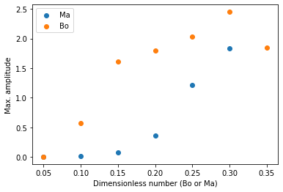

We clearly observe that at the same value, the amplitude is greater for the Bond number than the Marangoni number, which indicates that at this value of wave number, the Rayleigh-Taylor forces “dominate” over the Marangoni forces and are “more responsible” for the instabilities in the film.

The Bond number and Marangoni number reflect the parameters that are in the experimenter’s control; for instance, one could change the temperature of the wall to change the Marangoni number, or add an electric field to change the effective value of *g* and hence the Bond number. Thus, the above analysis illustrates the relative importance of those parameters in obtaining a given type of instability. That is to say, to obtain an instability corresponding to an amplitude of 2, we would need a Bond number of about 0.25 (in purely Rayleigh-Taylor behaviour) but a Marangoni number slightly more than 0.3 (in purely Marangoni behaviour)

#### Time-varying Marangoni Number

In this simulation, we attempt to see the effect of cooling the wall in real-time. We begin with a positive Ma = 0.1 at the initial time step, and then linearly decrease it. This will be analogous to gradually reducing the temperature of the wall.

The aim of this simulation was to see if an unstable film can be converted to a stable one by changing the temperature of the wall within one simulation only. We hoped to see the instabilities getting created, and then, after a critical Ma is achieved, getting dampened out by the now stronger surface tension forces.

For the purposes of this simulation, we have chosen the following parameters:

Bo = 0.45

k = 0.2

Ma = 0.1-0.000099t (since T = 750/0.083 = 9036.14, we have Ma varying from 0.1 to -0.7945)

The video for this can be accessed here: [Simulation Video](https://drive.google.com/file/d/1-R5QNZeit5QLJdaJGb8J-neZuWbdUxBl/view?usp=share_link)

#### 

#### Variations in Bi

For Bo=0.145, Ma=-0.145, K = 0.3

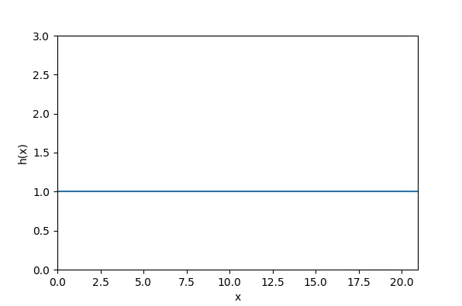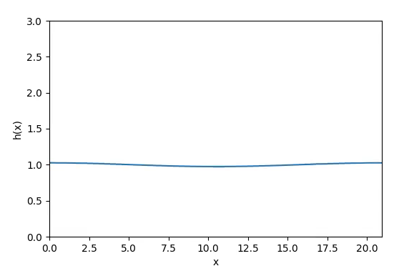

Bi = 1 Bi=14

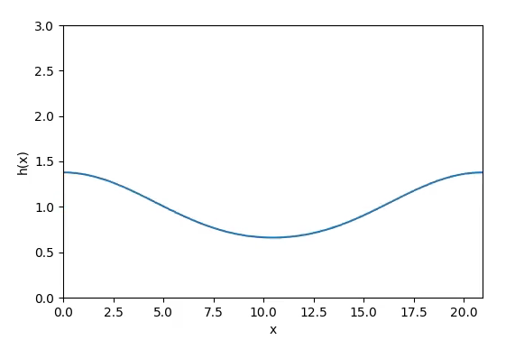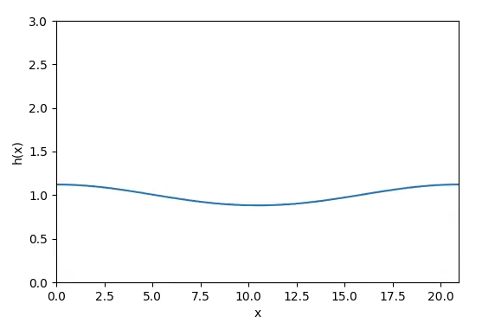

Bi= 15 Bi= 17

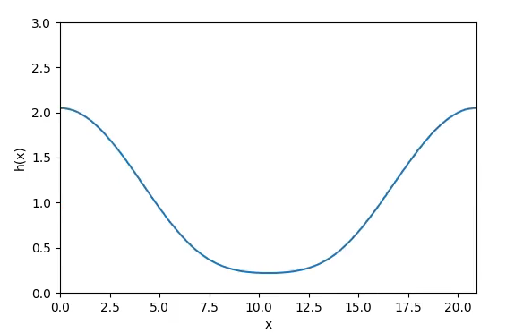

Bi= 50

Biot Number is the which is equivalent of ratio thermal diffusivity at surface to the thermal diffusivity of bulk. Large Bi is equivalent to saying internal diffusivity is quite low hence the wall take longer time to realize a different temperature at surface and vice-versa. Because of this Margoni effect will be dominated by Rayleigh-Taylor effect and film get destablished.

#### Miscellaneous Simulations (similar to Assignment 3)

1. **Random Initial Perturbations**

All of the videos for this set of simulations can be accessed [here](https://drive.google.com/drive/folders/1PLyjG7A9jf19ctxjMo4fU543g60jkva_?usp=share_link).

1. In an otherwise stable system: (Bo = 2, Ma = -6, k = 1)

At the given values of Bo, Ma and k, the system is known to be stable under a perturbation of the form In the following simulations, we impose randomly generated perturbations of different orders to see their effects. As we can see, the random perturbation merely shifts the baseline and does not create any instabilities.

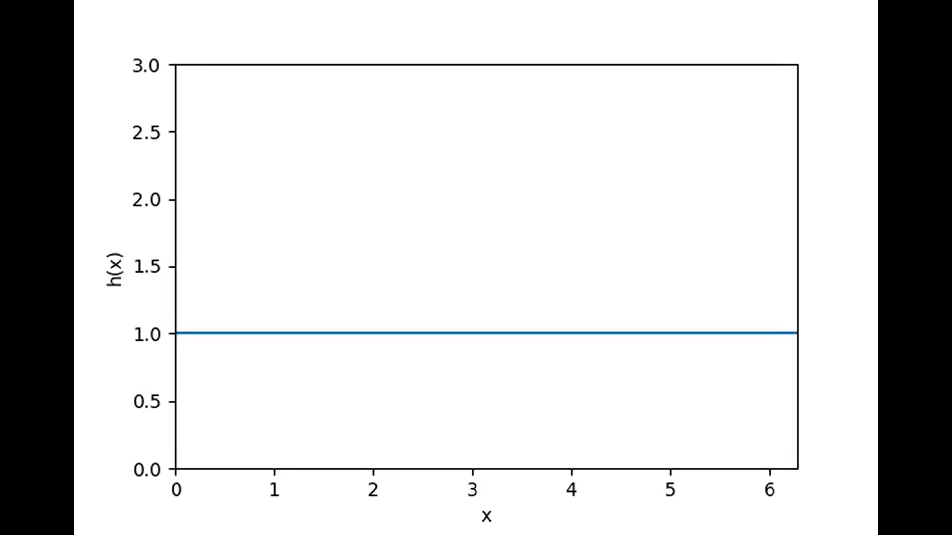pert = 0.00016121884340858605

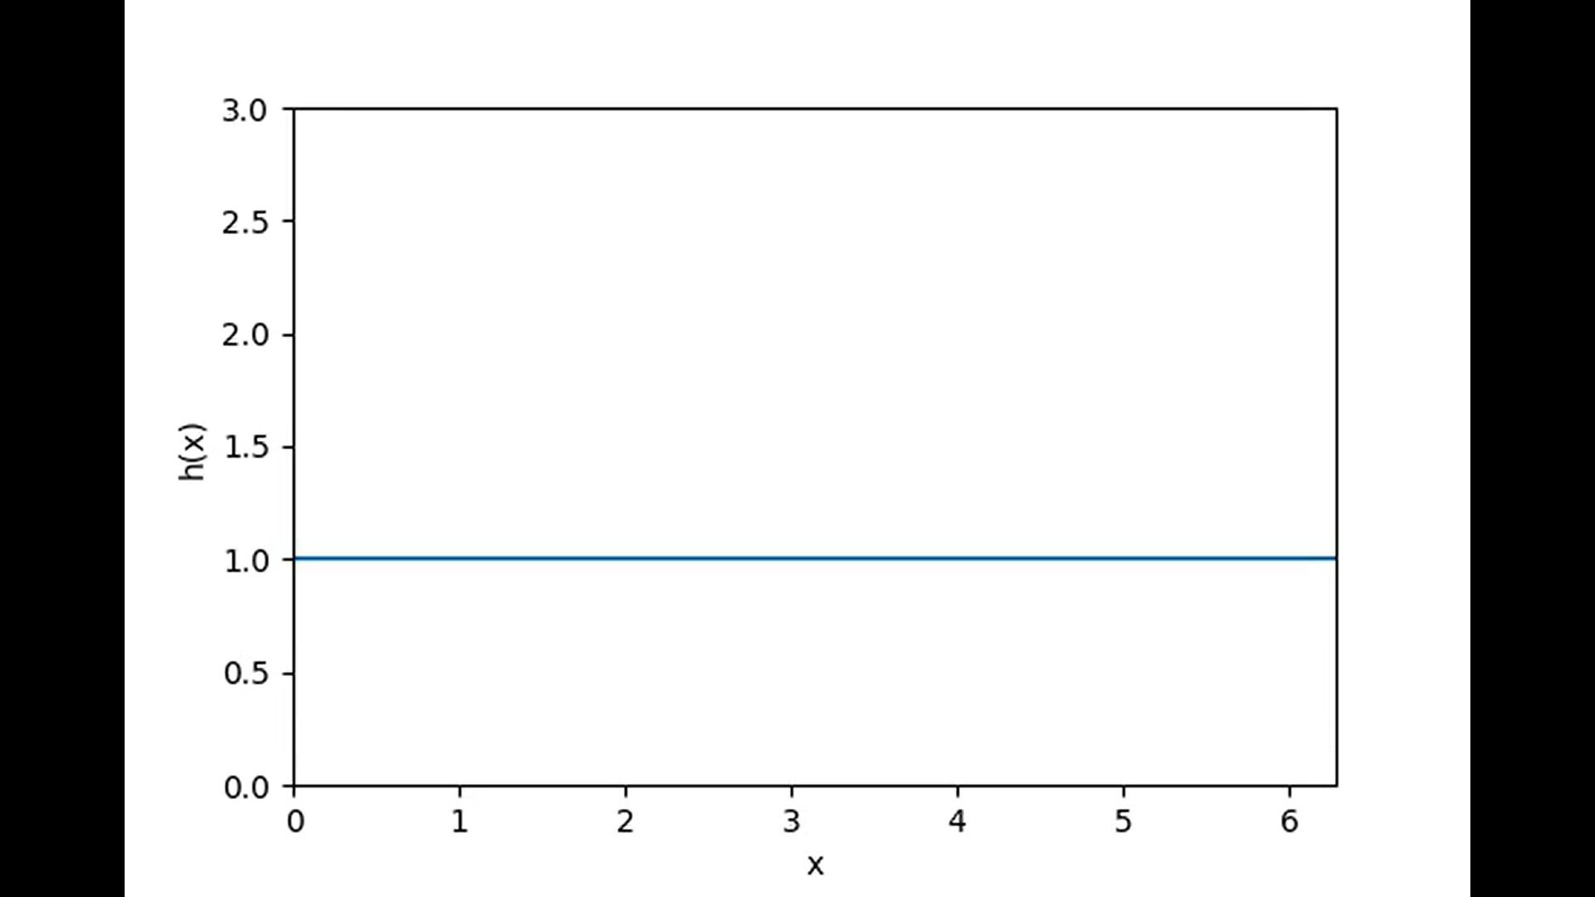pert = 0.00037613236200273936

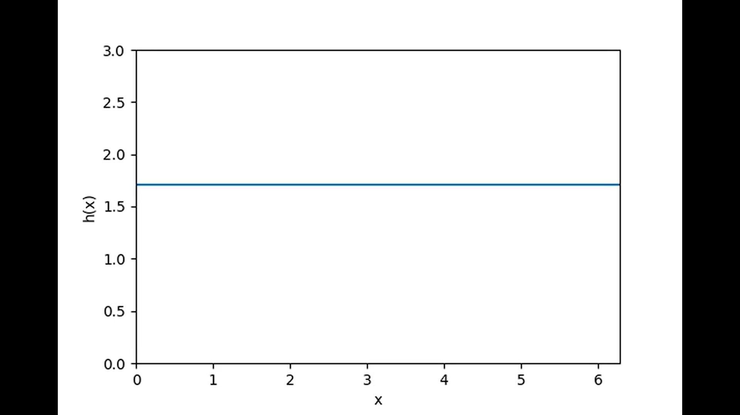pert = 0.7066079684409926

1. In an unstable system (Bo = 2, Ma = -1.5, k = 0.4)

At the given values of Bo, Ma and k, the system is known to be unstable under a perturbation of the form In the following simulations, we impose randomly generated perturbations of different orders to see their effects. As we can see, the random perturbation merely shifts the baseline and does not create any instabilities.

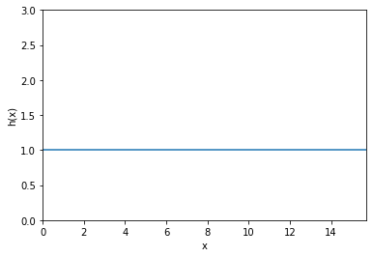Pert = 0.0003944516470165258

Pert = 0.0007631271177439803

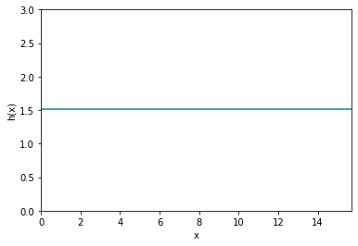Pert = 0.5189749825584619

1. **Two modes**

* Choose two unstable values of k, one as close as possible to the fastest growing mode, and another unstable but with a lower growth rate. Simulate the equation with an initial condition that contains both perturbations with equal amplitudes, A1 = A2 = 0.001. Do both modes appear or does one dominate the pattern?

The videos can be accessed [here](https://drive.google.com/drive/folders/1xfkj2Fk3JzxvMYxhdnIfER_X6X--2gpx?usp=share_link).

Let us consider Bo= 0.3 and Ma= 0.1. For such a system, maximum value of is obtained at k= 0.4108. changes sign at k= 0.5809. Let k1= 0.41 (Close to the fastest growing mode) and k2= 0.57 (Very low growth rate) With a perturbation of 0.001, we get

1. k1= 0.41, P= 0.001 k2= 0.57, P= 0.001

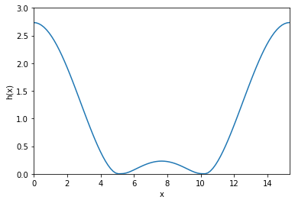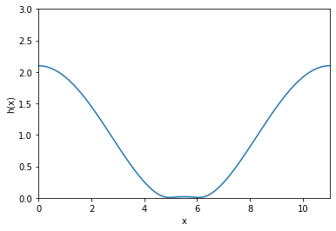

1. Now, when we operate both the modes together, for P= 0.001



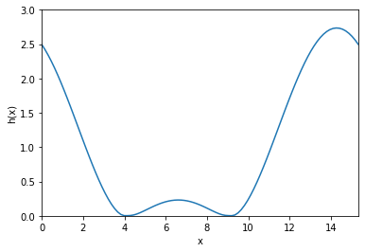

The mode closer to the fastest growing mode dominates (k1= 0.41) for P= 0.001

* Repeat the simulation again, but with larger initial amplitudes of A1 = A2 = 0.1. Is there any change in the result?

Keeping everything else constant, now, P= 0.1

1. k1= 0.41, P= 0.1 k2= 0.57, P= 0.1

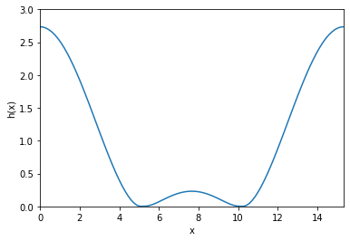 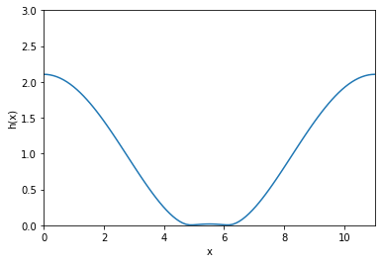

1. Now, when we operate both the modes together, for P= 0.1

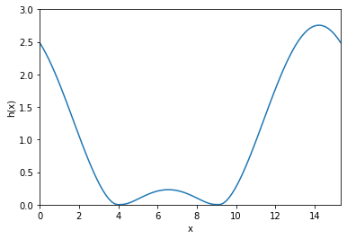

The mode closer to the fastest growing mode dominates (k1= 0.41) for P= 0.1

This is because the faster growing mode has higher and thus higher value of h’ that would dominate over the h’ coming from a mode with lower growth rate

### Links and References

[[1](https://en.wikipedia.org/wiki/Rayleigh%E2%80%93Taylor_instability)] <https://en.wikipedia.org/wiki/Rayleigh%25E2%2580%2593Taylor_instability>

[2] Dietze, G., Picardo, J., & Narayanan, R. (2018). Sliding instability of draining fluid films. Journal of Fluid Mechanics, 857, 111-141. doi:10.1017/jfm.2018.724

All of the videos and images generated in the analysis can be accessed through the following link: <https://drive.google.com/drive/folders/1TrLIlHVFfSA3G4e6-lKw1xe_m2DmydQH?usp=share_link>